**BALDERTON**

**NEEDS YOU !**

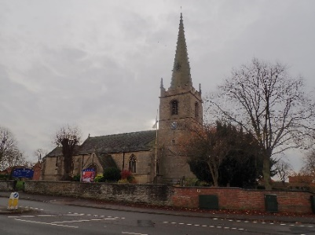

**Volunteers Wanted**

***For***

**Balderton Community Support**

Would YOU like to volunteer to provide support to members of your community? This could be :

l ***Shopping for Essentials*** l ***A Friendly Chat***

l ***Prescription Collections*** l ***Other Errands***

**Interested and want to know more?  
Contact: [Replace with contact details] baldertoncs@helpmystreet.org**

**www.helpmystreet.org/balderton**